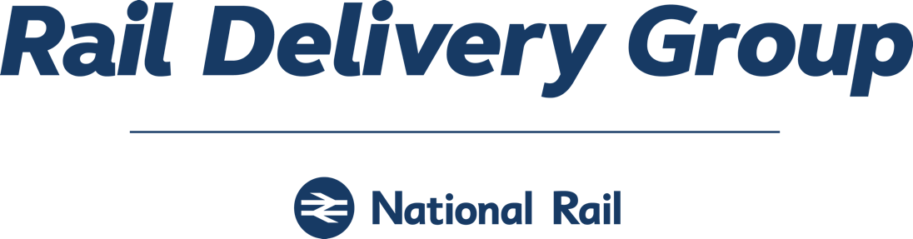

APPLICATION FOR RETAIL AGENTS:

THIRD PARTY RETAILER LICENCE
INTERNATIONAL SALES LICENCE
SEASON TICKET TRIAL BY THIRD PARTY RETAILERS

APPLICANT:
COMPANY NAME

 | NOTES TO APPLICANT
1. | The purpose of the attached form is to provide Rail Delivery Group with an overview of your company structure and plans for entering the rail retailing market, and the market you are proposing to enter.
2. | Please complete this form in as much detail as possible to enable us to make a preliminary assessment of your application (grey boxes will expand to accept text).
3. | Following receipt of your application we will begin high level discussions on the retailing licence you have applied for and associated commercial terms.
4. | If you are applying for a Third Party Investor Licence we would initially aim to agree an Interim Retail Licence with you in advance of pilot where, following a successful pilot phase, we would expect to you to be in a position to move to a Third Party Investor Licence, normally within six months of the start of operations
5. | If you are applying for a Third Party Retailing Licence, there is a licence application fee of £10,000 + VAT which will be due on signature of the Interim Retail Licence.
6.  7. | Please note that it is your responsibility to make early contact with the Rail Settlement  Plan TIS Accreditation team to ensure that your technical development and accreditation schedule corresponds to your plans for launching your service.  Please note that if the application is approved by the board, retailers are expected to commence trading within 6 months of the date the licence application is approved. If there is any delay, a 3- month can be considered, however any further delay may result in a fresh application being required in order for RDG to undertake due diligence.

1. COMPANY DETAILS

COMPANY
Registered Name legal name
Company Registration No.
Place of Incorporation VAT Registration No.
Trading Name
Trading Address
ADDRESSES
Company Registered Address
UK Business Address
for service of notices/documents
GROUP COMPANIES
Please provide details of any holding/parent, related or subsidiary companies
CONTACT DETAILS
Primary Contact
Job Title/Designation
Phone
Fax
Email
Secondary Contact
Job Title/Designation
Phone
Fax
Email
PRINCIPAL DIRECTORS
enter name & designation
OTHER RAIL LICENCES HELD
list here details of any other Rail Delivery Group/TOC licences held, or any rail operators/intermediaries in the UK or overseas for whom you act as sales agent in the UK
INVOLVEMENT OF TOC EMPLOYEES
list here names of any individuals connected with your organisation or licence application who are current, or recent (within past 6 months), TOC employees

2. FINANCIAL & LEGAL

BANK DETAILS
provide full details of bank which will be used for the operation of your service
(Please enclose a copy of your latest audited account; all applicants are subject to credit vetting)
LAWYERS
name, address, contact details
ACCOUNTANTS
name, address, contact details
TRADE REFERENCES
supply names/addresses of two registered companies (not subsidiary, holding or associated company of your company) that can be approached for a reference
Trade Reference 1
Trade Reference 2

3. LICENCE BEING APPLIED FOR

Please indicate the licence type you are applying for:

Third Party  Investor  Licence |  | International  Licence |  | Season  Retailing  Licence

4. PROPOSED STRATEGY & TECHNOLOGY

Please outline below the key features of your planned approach to the market, for example:
- your key competences
- market sectors you plan to enter (B2B, B2C)
- fulfilment and customer support structures, you will put in place to meet the Rail Delivery Group retailing standards
- your proposed timescales for development and launch

Please provide details of the Ticket Issuing System (TIS) and other supporting systems you are currently using.
If you are entering the market for the first time, please indicate whether you are planning to build your own TIS or to procure a system from a TIS supplier.
NOTE: TIS Accreditation process is separate from this Licence Application. Please contact the RSP TIS Accreditation team to discuss your proposed development and schedule for launch.

Customer Proposition:
- Please describe your offer including your key audiences, key markets and customer benefits.
- What’s your unique selling point? How do you plan to differentiate your offer from the competition?
- What risk may be associated with your product?
- What opportunity are you tapping into?
- How do you plan to grow the market for UK rail?
- Where do you see this growth coming from?

Marketing Plan:
- How do you plan to promote your product?
- What market segment/s are you targeting?
- How would you share customer data with TOCs (Train Operating Companies)?

Company Structure
- Explain the structure of your organisation including the ownership.
- Are there any plans in 1-5 years that will result in either changing ownership or change in management team?
- Any conflict of interest considerations? Do you have any other rail activity or interest?

Please list below those Rail Products you plan to sell in addition the list of mandatory products.

Please indicate below the Methods of Retailing you plan to use (web, telesales, kiosks, mobile, App)
If you are already trading, please also list, as appropriate, website URLs, call centre, phone numbers and National Location Codes (NLCs)

5. PERIODIC REVENUE SALES FORECAST

YEAR 1

YEAR 2

YEAR 3

(in GBP £)
Please note that the above sales forecast will be used to calculate the bond requirements.

6. DECLARATION

I confirm that, to the best of my knowledge, all information provided in support of this Third Party retailing licence application is complete and accurate.

I understand that the provision of any false or misleading information may result in the refusal of this application.

SIGNED: | ___________________________________
PRINT NAME: | ___________________________________
DESIGNATION: | ___________________________________
DATE: | ___________________________________

Please forward your completed Application to:

Philip Barnard
Rail Delivery Group
First Floor North, 1 Puddle Dock,
London EC4V 3DS
Email: philip.barnard@raildeliverygroup.com

